List of error if we are receiving then we have to check and update client number:
error -OVERPAYMENT: PURCHASE AMOUNT AND MODAL BENEFIT INCOMPATIBLE
or
If requester is getting any error messages in AUPD when trying to update client number, I've asked her to send to us to create the client update transaction. I don't want her to change any other values on the policy.
Or
Name was blank for policyin STDNAM1 file.
Job ABCD518A was abended into ST02#03 with return code 0004.
Process to place transaction:
we have the field code list in RPS info sheet as per request we need to take filed code and then the new value (client number) right after that.
How to update transaction file below is the example:
For Policy check RPS screen and CBAS to verify what all client numbers are incorrect
On RPS
RGG1 screen
RIG1 screen
ON CBAS
CLIENTNO ROLE
PAYEE,LIFE ASSURED, ANNUITANT
In this case PAYEE,LIFE ASSURED, ANNUITANT client numbers are incorrect, so we have to create 3 transactions like below.
First check correct field code from RPS_info sheet
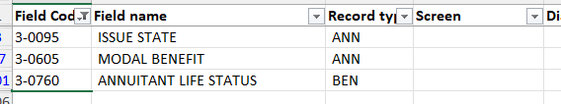
update correct company and case here it is 015
Update correct policy number and DATE will be todays( the day we are placing transaction)
Update correct field code as per requirement and place correct client number just after that.
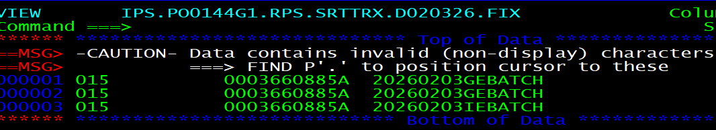
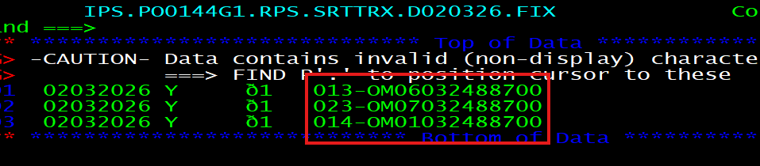
After updating send it to Karen for review, if all looks good place those transactions into below file latest generation
PSTIBS.LA00.XXX.SRTTRX.*

